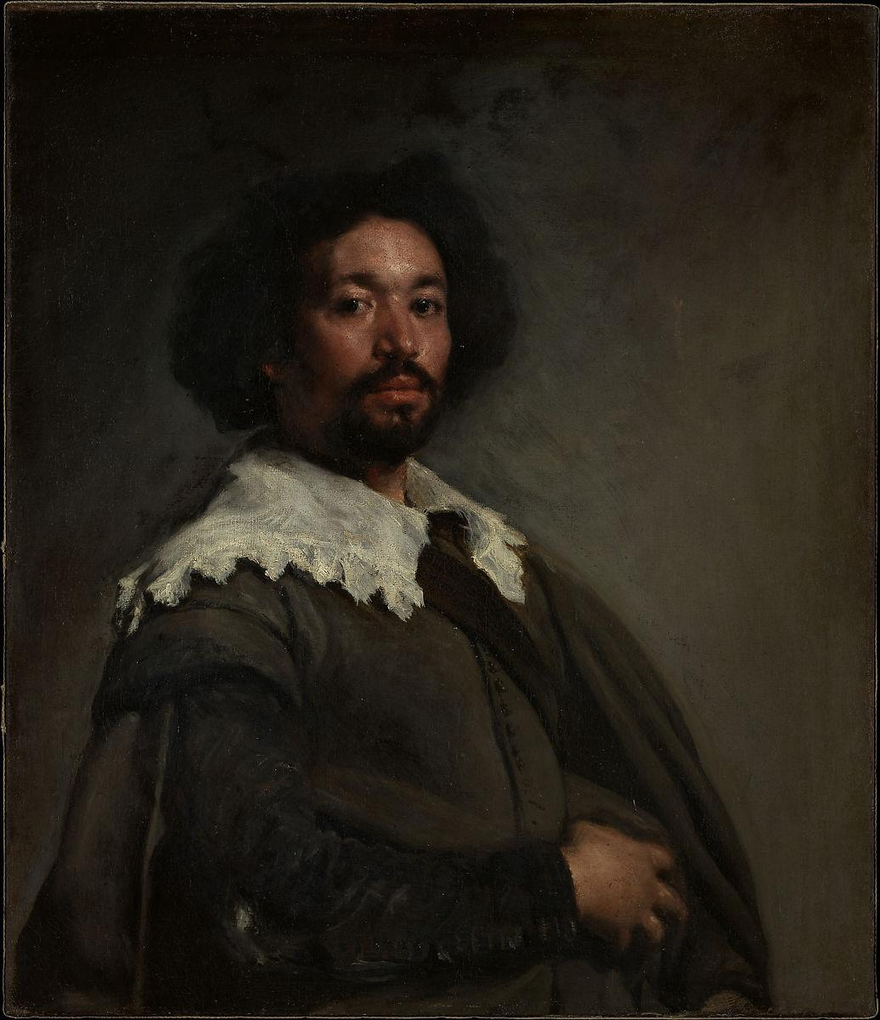

Portrait of Juan de Pareja, Diego Velazquez, 1650, Metropolitan Museum of Art, New York, USA

We return to Espana.

Although, inevitably, we will end up in Italia.

Velazquez’s Portrait of Juan de Pareja (above) is considered to be one of the great portraits ever painted. But all Diego cared about (like a Trump cabinet official) was an audience of one.

We’ll get to that in a minute.

First, some background on the painting.

In 1649, as court painter to King Phillip IV of Spain, Diego V. was sent to Rome to purchase works of art to stock up the collection at the Alcazar (the Buckingham Palace of Spain).

Velazquez brought Juan de Pareja with him on the journey- as de Pareja, a skilled artist in his own right, was an assistant in Velazquez’s workshop.

He was also a slave.

But Diego didn’t decide to paint him as a demonstration of heightened consciousness or as a call for emancipation. He wasn’t trying to make a statement.

He was trying to secure a commission.

One that would further enhance his growing reputation.

While Diego was in Roma, Velazquez was granted an audience with the pope- the cranky and wily Innocent X (with as inaccurate a choice of a name if there ever was one). During the meeting Velazquez- knowing what it would mean to his career- offered to paint the Pope’s portrait.

But the Pope deferred, highly skeptical of the artist. As the Pope was highly skeptical of everyone. And Diego was Spanish, for God sake. And while he was a known artist, he was a relative stranger.

No dice, said Il Papa.

But Diego wasn’t about to give up so easily. He continued to pursue the matter, to the point where the crafty Pope- still reluctant- asked to see other portraits that Velazquez had done. To see if Velazquez cut the mustard.

The Pope was a sly dog. He knew all of Velazquez’s paintings were far away back in Spain; He knew Diego couldn’t produce any of his works. It was Innocent’s way of giving him the brush- off (literally).

But not so fast Innocent X.

Velazquez was determined, and with no other options, Diego V. decided to paint a new portrait to demonstrate his skill. And the most convenient sitter for this portrait was his slave assistant.

(It turned out to be the first time a black Spanish man was ever the subject of a painting (sometimes progress happens by happenstance)).

Innocent liked the muted tones of the painting and how Diego had portrayed de Pareja in a dignified and elegant manner. If he could do that for a slave, the Pope thought, finally agreeing to the portrait, imagine what he could do for me.

He was about to find out.

. 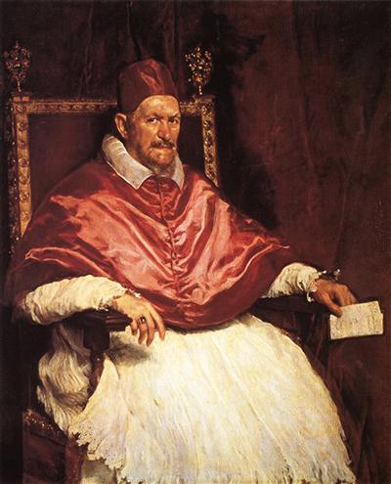

Portrait of Innocent X, Diego Velazquez, 1650, Galleria Doria Pamphili, Rome, Italy

As it turned out, the Pope was right to have been reluctant to sit for the Spaniard, as Velazquez captured the pontiff’s cagey, cynical, wary, shrewd, essence.

It turned out to be a bit more realistic than the Pope was looking for.

The portrait surprised the Pope as it was in sharp contrast to the flattering portraits that were expected and had previously been standard issue for popes (with the exception of Raphael’s painting of Julius II, where other motives were at work)

Innocent loved the power the painting exuded (the contrast of bold reds against the innocence (get it?) of white) but hated that Diego had captured his menacing glare and impatient nature..

But he should have known better.

Apparently, when the pontiff first saw the finished portrait of de Pareja, the disconcerted Pope’s initial reaction was to exclaim: “It’s too true, it’s too true”.

So he should have known what he was getting himself into.

Because Diego did, in fact, paint him “too true”. So much so that, while the Pope admired the work, it was kept private, away from the public (in fact, it has only been made available for public consumption by the family within the last thirty years).

The public was not about to get access to a portrait where the Pope is staring down the viewer, appearing irritable, ambitious, angry, plotting and more- like he is about to rise from his chair and tell Velasquez to forget the whole thing.

But now, after all these years, we can finally see Innocent X for all he was.

Much to his chagrin.

A few tidbits:

The acorns on the back of the chair, placed there by Velazquez, are a symbol of the Pamphili family.

Velazquez had previously painted a portrait of King Phillip IV of Spain in a single day (kings, apparently, unlike certain presidents, are busy people).

Diego V. signed his portrait of Innocent X. Search for it.

(It’s on the piece of paper that the impatient Pope is holding in his hand).

A contemporary described Innocent X as follows: “Tall in stature, thin, choleric, splenetic with a red face, bald in front- with thick eyebrows bent above the nose that revealed a severity and a harshness.”

I’m not sure I follow every word of that, but it doesn’t sound very flattering.

In other words, Diego seems to have gotten him about right.

Another small insight into the personality of Innocent: When he secured the papal chair, he immediately pursued the family of his predecessor (the famous Barberini clan), accusing them of embezzlement of public funds (which might have been fair). The remaining Barberini- three in all- fled to France, where they were given protection by the French Cardinal Mazarin.

As a result, Innocent X confiscated all Barberini properties on the Italian peninsula.

And he wasn’t very well liked. During his reign, the artist Guido Reni (an underrated painter and supporter of the Barberini), painted The Archangel Michael defeating Satan. In the work, he portrayed Satan with the features of Innocent X. Reni then fled the Papal States

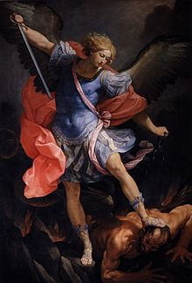

The Archangel Michael Defeating Satan, Guido Reni, 1635, Santa Maria della Concezione de Cappuccini, Rome, Italy

So apparently he wasn’t the nicest guy.

But to counterbalance this unconditionally negative portrayal (and to give the man a break), I will point out that Innocent X supported the independence of Ireland from England- even sending arms to the Irish.

So he wasn’t all bad.